Final Project

Credit Card Default Predictor

* Akarsh Gaonkar

The data set I picked for this project is a credit card statement defaulting data set. It includes data regarding credit card balance limit, marriage details, age, gender, percentage of paid credit card statements for the past six months, delay in payment for the past 6 months and whether or not a person defaulted their payment for the most recent month.

The project agenda is divided into two parts:

1. The first part is to predict the right credit card balance limit a person should be permitted to have. This can be predicted using other predictor variables in the data set. Since the balance limit is a quantitative variable, we use regression models to be able to predict it. The regression models can be compared using parameters like the RMSE (root mean squared error). For this I will be choosing models that are best for linear regression. For the regression part I ended up using models like multiple linear regression, ridge regression, lasso regression, random forest and XGBoost
2. The second part of this project is to predict the default variable that is in levels of 0 and 1. 0 would mean that the user paid back the with credit card statements and 1 would mean that they defaulted their payments. This is a qualitative variable and hence the logistic regression along with other classification type must be used to be able to predict the default variable. For the classification models I ended up using a full logistic model, a linear kernel SVM, a radial kernel SVM, LDA and a neural net.

Why predict the right credit balance limit or if the credit card user is going to default their payment for a certain month?

* Capital One said recently that its annualized credit card write-off rate, the percentage of its overall loans considered unrecoverable or defaulted, hit 6.1%, up from 5.2% a year ago.
* Federal Reserve data shows U.S. credit card debt continuing to climb, reaching $5.113 trillion in October, compared to $5.093 trillion in September.

From the above stats we can see that minimizing human error while handing out credit card plans could save financial companies large sums of money. Choosing the right credit card balance limit and picking the right customers to hand out credit card plans to, can be key in maximizing monetary gain for financial institutions.

**Data Pre-processing**

* The data set includes 6 bill columns representing a customer’s credit card bill for six consecutive months and the amount they fulfilled for those six months. I condensed these twelve columns into six “percent paid” columns.
* Converted variables like Sex, Marriage and Education into factor data types
* Split the data set into training and testing
* Checked and eliminated NA values.

**Regression**

**Linear Regression**

Linear regression is a very popular procedure for modeling the value of one variable on the value(s) of one or more other variables. The variable that we're trying to model or predict is known as the dependent variable, and the variables that we use to make predictions are known as independent variables, or covariates. Linear regression makes the assumption that the changes in the dependent variable can be modeled as a monotonic linear function of the independent variables; that is, we assume that a change of a certain amount in the independent variables will result in a change in the dependent variable, and the amount of change in the dependent variable is constant across the range of the independent variables. As a simple example, suppose we're interested in the relationship between the horsepower of a car (the independent variable) and the miles per gallon of gas (MPG) of the car. When we fit a linear regression model, we're saying that a change of one horsepower will have the same effect on the MPG regardless of the value of horsepower that we're changing. In other words, a linear regression model would assume that if we had a car with 100 horsepower, and compared it to a car with 101 horsepower, we'd see the same difference in MPG as if we had a car with 300 horsepower and compared it to a car with 301 horsepower. Relationships like this often hold for a limited range of independent variable values, but the linear regression model assumes that it applies for the entire range of the independent variables.

Even with these limitations, linear regression has proven itself to be a very valuable tool for modeling, and it's widely used in many branches of research. There are also a variety of diagnostic measures, both numerical and graphical, that can help us to determine whether the regression is doing a good job, so it's not unreasonable that many people use linear regression as their first tool when trying to model a variable of interest. (*Berkley Stats, Linear regression*)

yi = b0 + b1 x1 + b2 x2 + ... + bp xp + ei      for i=1,2,3,...

The linear model that I used to predict the limit balance of a credit card user has a RMSE of 117233.7. This means that for every prediction that the lm() function makes for the limit balance variable, it is off from the actual value by an average of 117233.7. Considering that the dataset has limit balance values in hundreds of thousands and has the training set by itself has about observations, it is possible that the RMSE is so large.

From the below image, we see that the residuals of the fitted values are not randomly spread , in other words, this means that the linear model fails to capture some relationship we may not be seeing. This suggests that a linear model may not be the right option in this case.

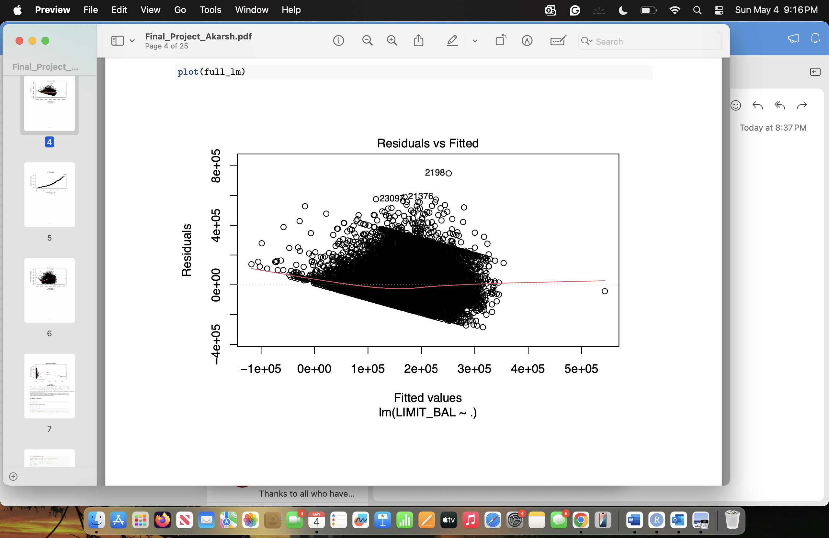

**Ridge Regression**

Ridge regression improves upon an ordinary linear model by adding a regularization term to the loss function. While a linear model only minimizes the sum of squared residuals, ridge regression minimizes the RSS plus a penalty proportional to the sum of the squared coefficients (controlled by a tuning parameter lambda). This "shrinkage" effect pulls the coefficients closer to zero without setting them exactly to zero. The key advantage is that ridge regression reduces variance dramatically, especially when predictors are highly correlated or when the number of predictors is large relative to the number of observations. Although it introduces a small amount of bias, this trade-off often leads to lower test error and more stable predictions compared to ordinary linear model. Ridge regression also prevents overfitting, whereas an RSS model can suffer from extremely high variance and unstable coefficients, particularly when predictors are multicollinear. The advantage of a ridge regression model is that it can reduce low effect variables by adjusting their coefficients but retains the variable to capture collinearity within the dataset. (*Shrinkage Methods, notes)*

The RMSE value of my ridge regression model is 116581. This is slightly better than the linear model. This shows that there may be correlated variables within the dataset. Below is a representation of how the variables in the dataset are weighed based on lambda values.

Below is what the penalty term looks like or a ridge regression model, if you notice, the penalty term is a square of coefficients.



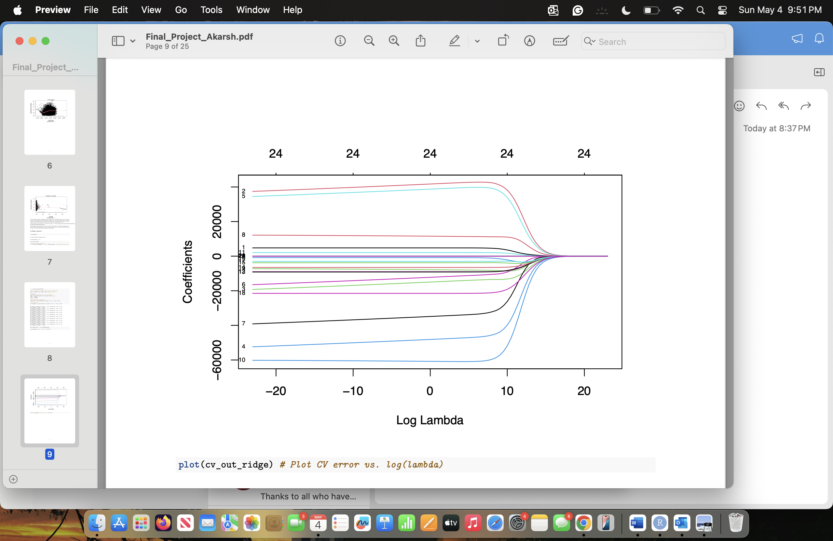

We see that variable 2, 5, 4, 10, and so on carry the most weight as compared to the rest of the variables.

**Lasso Regression**

Lasso regression improves predictive modeling by adding a penalty to the absolute values of the coefficients. It minimizes the residual sum of squares by including absolute value of the penalty term. This penalty shrinks some coefficients exactly to zero, allowing Lasso to perform automatic feature selection. In contrast, Ridge regression adds an L2 penalty: (includes square of penalty term), which shrinks coefficients toward zero but never exactly zero. Ridge keeps all predictors, making it more suitable when many variables have moderate importance. Lasso works best when only a small subset of predictors is truly relevant and when model simplicity is a goal. Both methods balance the bias-variance trade-off, reducing overfitting compared to a

regular linear model. Cross-validation is typically used to select the tuning parameter Lambda. In short, Lasso shrinks and pushes low impact variables to 0, while Ridge shrinks but keeps all predictors. Hence Lasso models also tend to be computationally light.

The RMSE value of my lasso regression model is 116499. This is minimally better than the linear model, and may be relatively similar to the ridge regression model, suggesting that the lasso model doesn’t do much better than the ridge regression model because there are collinear variables in the dataset. Below is what the penalty term looks like for a lasso regression model.

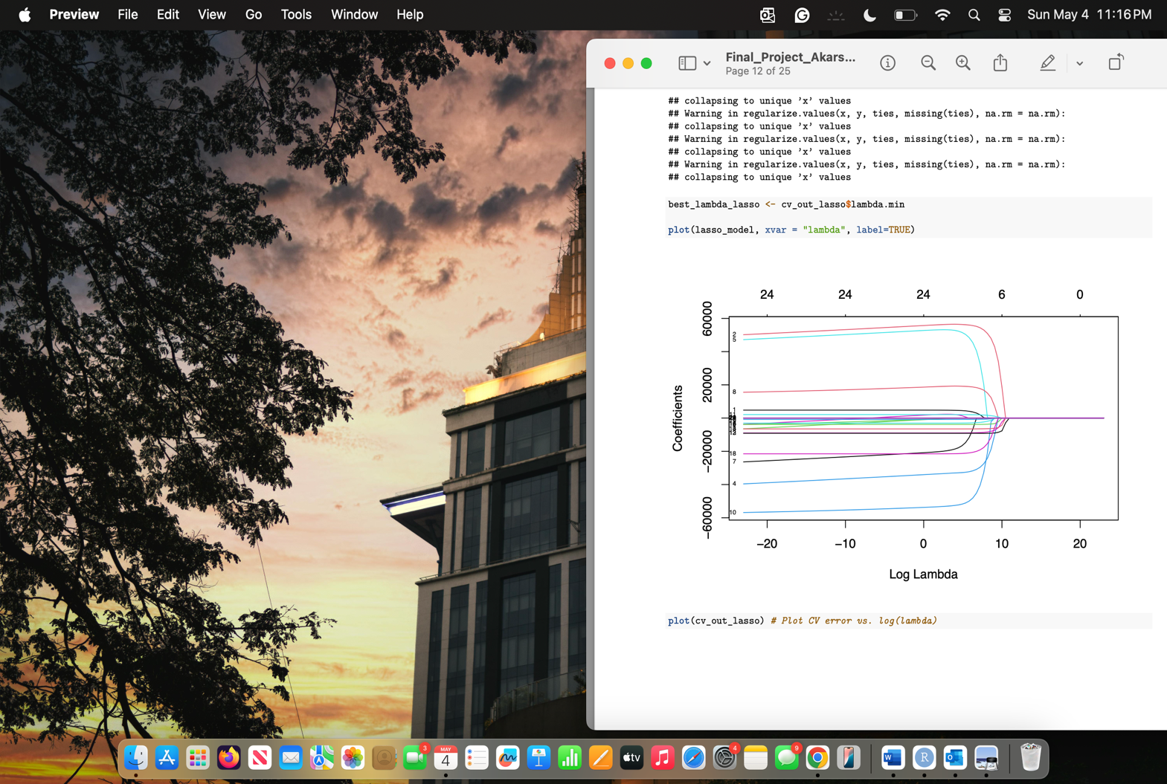



Coefficients are pushed to 0 because of the change in penalty term.

**Random Forest Regression**

Random Forest Regression is a powerful and flexible modeling technique that makes very few assumptions about the underlying data. It does not assume linearity, normality, or constant variance, making it ideal for complex, real-world datasets. Its strengths include handling nonlinear relationships, high-dimensional data, multicollinearity, and outliers naturally, while also providing automatic measures of feature importance. Random Forests reduce overfitting by averaging many decision trees, leading to strong predictive performance. However, they are considered "black box" models, meaning their internal decision-making is hard to interpret. They can also be computationally intensive, especially with large datasets or many trees, and they are not good at extrapolating beyond the range of training data. Additionally, they may show

a bias toward predictors with many possible split points. Overall, Random Forest Regression is an excellent choice when prediction accuracy is more important than model interpretability, particularly for messy or highly nonlinear data. (*Geeks for geeks, Random forest regression)*

I chose an mtry value of 4 for this dataset as it is a good point to choose the root of the total number of variables being for the training of the model.

The RMSE value for my random forest model is 106709. This is better than the lasso and ridge regression models. From the text above, it makes sense that the random forest model does better on real world data sets because the credit card default dataset is a real-world dataset. This model does better because it handles nonlinear relationships, high-dimensional data, multicollinearity, and outliers better as compared to a linear regression model

Below is an intuitive idea of how a random forest model works.

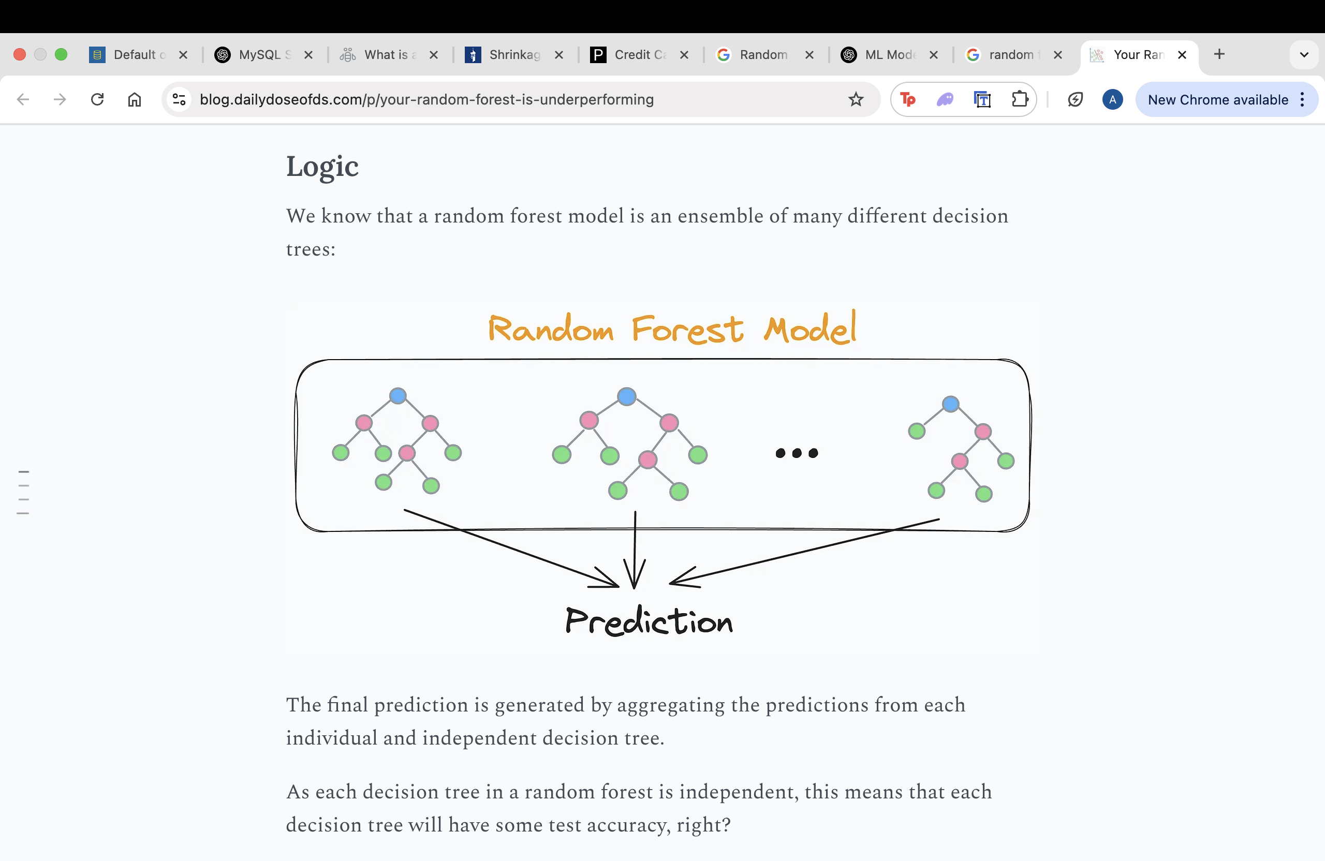

**XGBoost Regression (Extreme Gradient Boosting)**

XGBoost (extreme Gradient Boosting) is an advanced machine learning algorithm based on the gradient boosting framework. It belongs to a family of ensemble methods, which combine multiple weak models, typically decision trees, into a single, stronger model. Unlike traditional models like decision trees and random forests that are easier to interpret but may struggle with complex datasets, XGBoost is optimized for accuracy, speed, and scalability. It builds decision trees sequentially, where each new tree is trained to correct the errors of the previous one. The process begins with a base learner (often predicting the mean in regression tasks), followed by calculating residuals or errors. The next tree then focuses on learning from those residuals. This cycle continues until a stopping condition is met, such as a maximum number of trees or minimal improvement. XGBoost includes built-in regularization, parallel processing, and support for custom loss functions, making it efficient and highly tunable for different tasks. The final prediction is a weighted sum of predictions from all individual trees. Due to its robustness and high performance, XGBoost is widely used in machine learning competitions and real-world applications involving structured data. It consistently outperforms many traditional models when tuned correctly.

The above XGboost has an RMSE of 106852. The model does relatively as well as the random forest model. It is probably because the random forest model is tuned to its best form and ties the performance of the boosted model. (*Geeks for geeks, XGboost*)

The gradient boosting model maybe the model with the most potential among the models used so far, provided the model is tuned right and the data is preprocessed correctly. It is to note that the data set I am working with is imbalanced, meaning there is more non-defaulted customers as compared to defaulted customers. In a real-world scenario, it is advised that the data is balanced using techniques like imputation or picking equal number of training values from each training class. This makes sure that the model is trained in a balanced manner.

**Classification models to predict if a customer is going to default their payments.**

**Logistic Model**

This logistic model has a accuracy of 82.4% with a slightly adjusted threshold. Intuitively, the logistic function models the probability of a data point belonging to class with label 1. The reason for that is that the output of the logistic function is bounded between 0 and 1, and we want our model to capture the probability of a feature having a specific label. For instance, after we have trained logistic regression, we obtain the output of the logistic function for a new data point. If the value of the output is greater than 0.5, we classify it with label 1; otherwise, we classify it with label 0. To be able to do this, some preprocessing was needed. It required me separate the result labels from the test set and store it as a factor vector. After the predictions were made, it needed classification into binary factors based on the predicted probabilities.

Logistic regression assumes that the outcome variable is binary, meaning it has two categories such as yes/no or 1/0. It also assumes a linear relationship between the predictors and the log-odds of the outcome. Additionally, the model requires that there are no extreme or influential outliers among the continuous predictors, and that the predictors are not highly correlated with each other, which would indicate multicollinearity. (*STDHA, Logistic Model Essentials*)

The *glm()* model that I used has an accuracy of 82% and a kappa value of 0.36. This is a decent accuracy rate to predict the right classification for a data value, giving us a good baseline to compare to. Talking about the kappa value: 1 = perfect agreement, 0.8-0.6 is substantial agreement, 0.4-0.6 is moderate agreement, 0.4 – 0.2 is fair agreement and anything below 0.2 is none to slight agreement. With a kappa value of 0.36, it is to mention that there is a fair agreement.

An intuitive understanding of kappa values: Cohen’s Kappa corrects for the possibility of agreement occurring by chance alone. This is particularly useful in situations where there may be a high degree of agreement by random chance, especially if the classes are imbalanced. Hence, given that the dataset being used here is imbalanced, it is fair to use the kappa values as a comparison model for the models as it accounts for agreement by chance.

The 82.30% accuracy of the model means that there is a 82.30% chance of labelling the credit card client correctly, on whether they will default their credit card statements or not. The balanced accuracy of this model was 65%. (Balanced accuracy is the accuracy of the model, after penalizing for chance agreement)

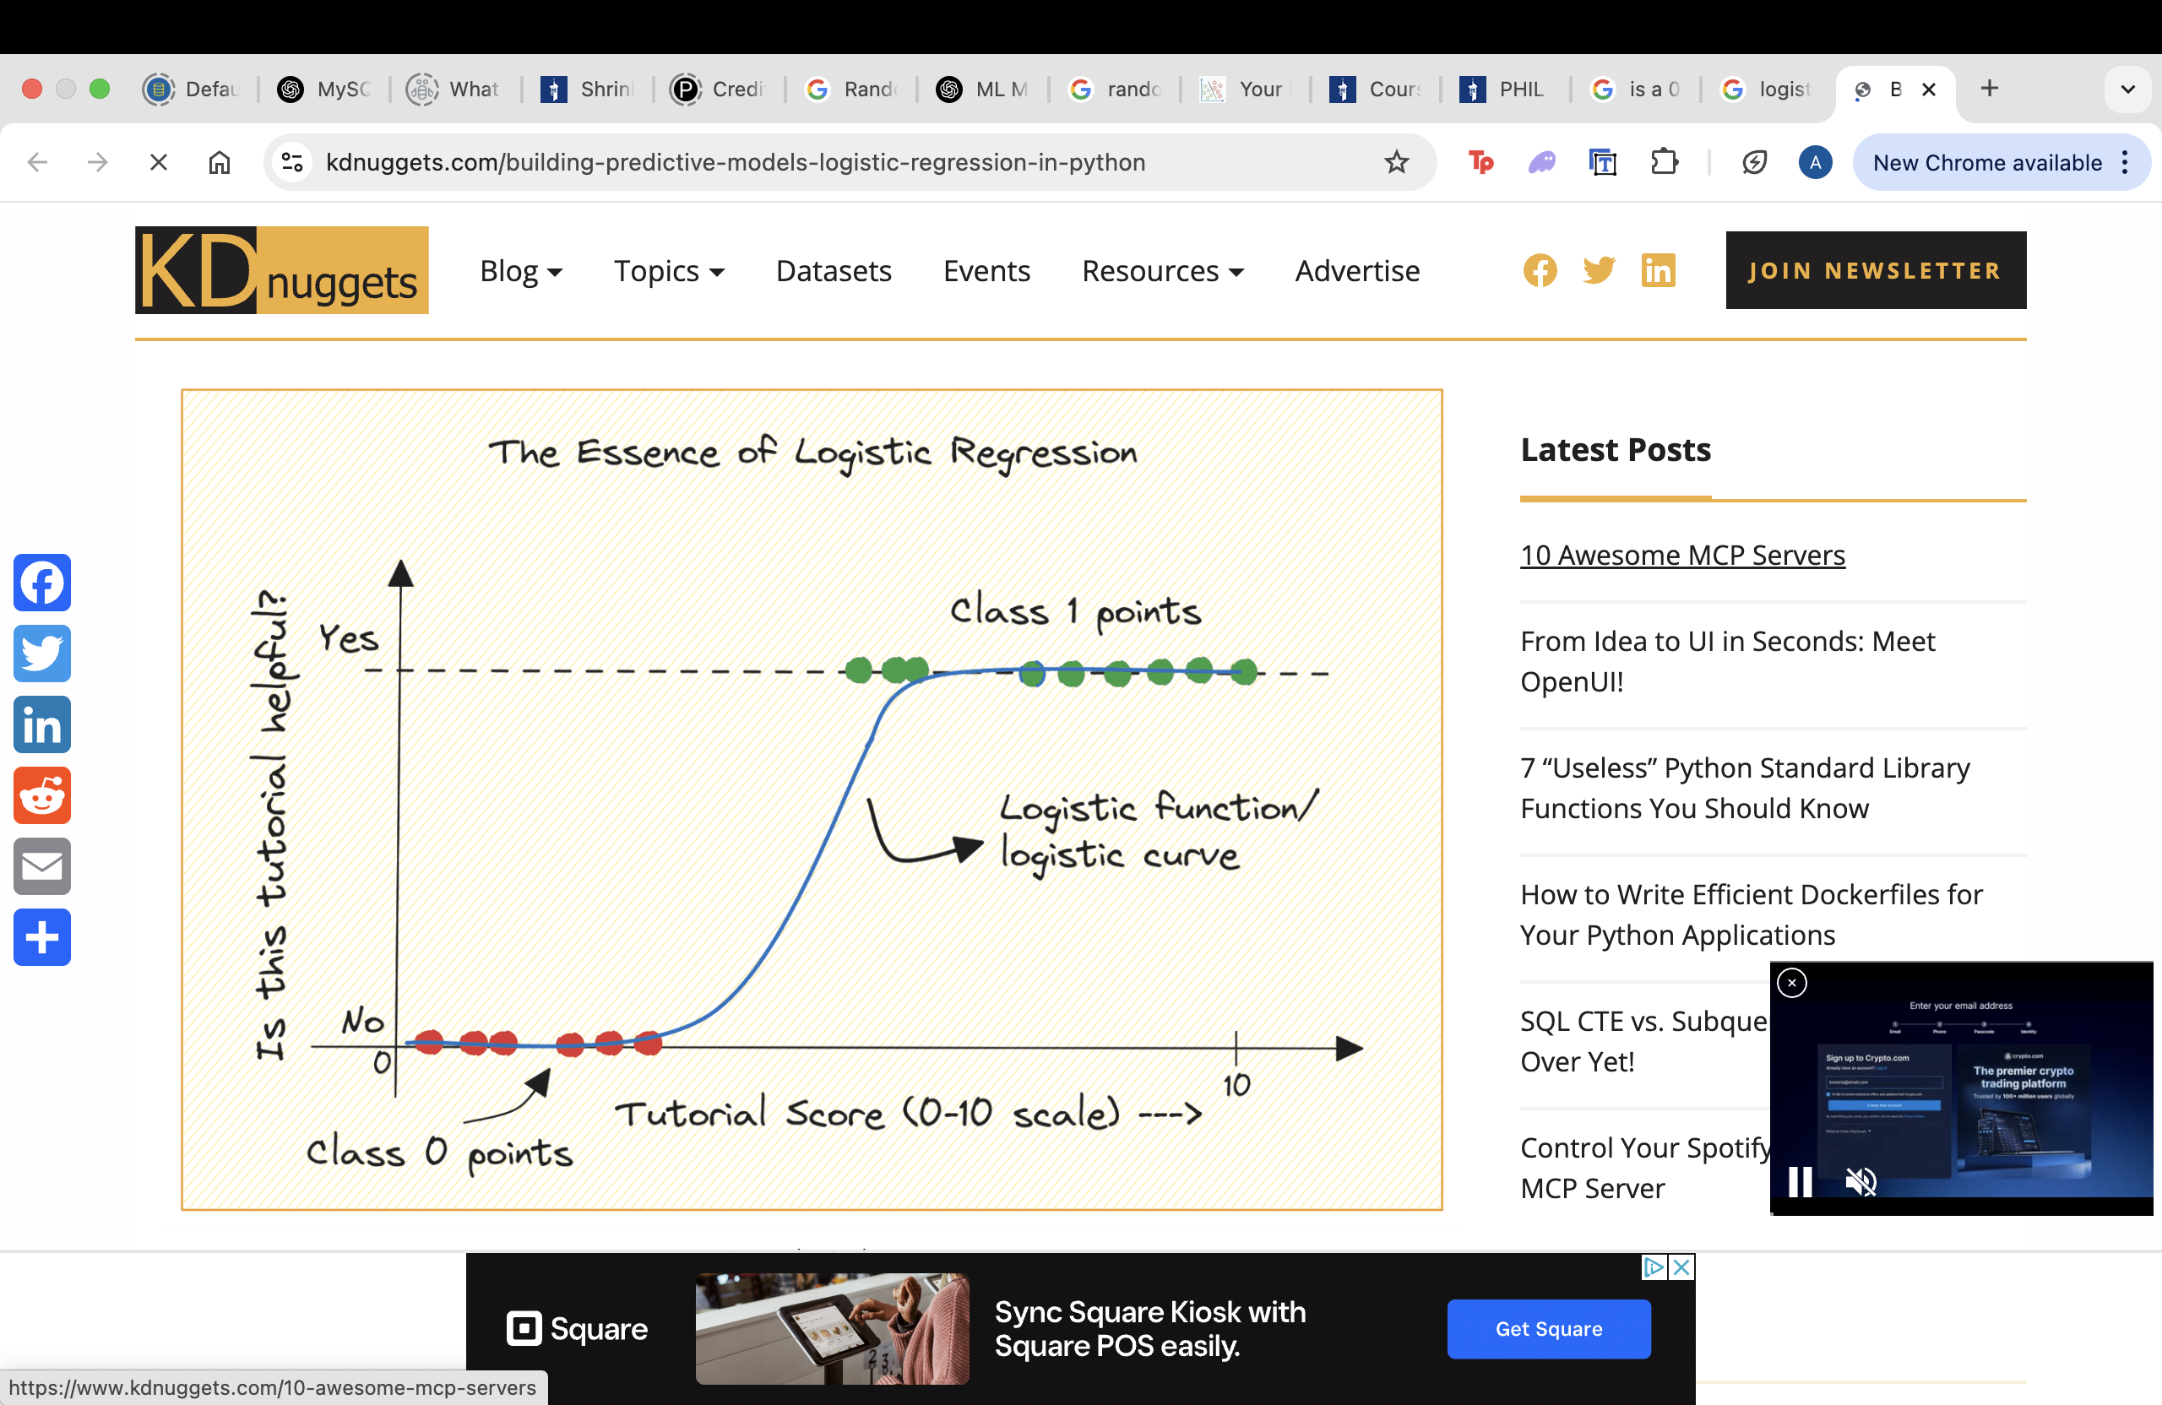

**SVM (Support vector machines, linear kernel)**

SVMs are commonly used within classification problems. They distinguish between two classes by finding the optimal hyperplane that maximizes the margin between the closest data points of opposite classes. The number of features in the input data determine if the hyperplane is a line in a 2-D space or a plane in a n-dimensional space. Since multiple hyperplanes can be found to differentiate classes, maximizing the margin between points enables the algorithm to find the best decision boundary between classes. This, in turn, enables it to generalize well to new data and make accurate classification predictions. The lines that are adjacent to the optimal hyperplane are known as support vectors as these vectors run through the data points that determine the maximal margin. The SVM algorithm is widely used in machine learning as it can handle both linear and nonlinear classification tasks. However, when the data is not linearly separable, kernel functions are used to transform the data higher-dimensional space to enable linear separation. This application of kernel functions can be known as the “kernel trick”, and the choice of kernel function, such as linear kernels, polynomial kernels, radial basis function (RBF) kernels, or sigmoid kernels, depends on data characteristics and the specific use case. (*IBM, Support Vector Machines*). In the linear kernel SVM is the simplest of the three options we have, It is used when the data may be linearly separable.



Cost is one of the adjustable parameters. The cost value helps to smoothen the decision boundary and regularize the data. In simple words, a low cost value captures less variance and a large cost value will capture more variance, which means that theoretically, too large of a cost value could cause overfitting.

The accuracy of the SVM model is 81.2%. It means that the SVM model would classify the default status of a credit card client correctly, approximately 81/100 times. The kappa value for this model was 0.27, suggesting fair agreement. The balanced accuracy of this model is 75%, which is almost a 10% jump in balanced accuracy as compared to the logistic model.

**SVM (Support vector machines, radial kernel)**

When using radial SVM, there are several important parameters that can be tuned to optimize the performance of the model. The most important parameters are C and gamma. The C parameter controls the trade-off between achieving a low training error and a low testing error, with a high value of C indicating a preference for a low training error over a low testing error. The gamma parameter controls the shape of the decision boundary, with a high value of gamma resulting in a more complex and wigglier boundary. (*Geeks for Geeks, Support Vector Machines*)

To find the optimal values for these parameters, I used a grid search over a range of values cost and gamma values, and I found the optimal cost and gamma values to be 1 and 4 respectively. I commented out the code at the time of knitting the file as it is computationally heavy and time consuming. The accuracy I had for this model was 81.64%, with a kappa value of 0.32, which represents fair agreement. After using the kappa value to account for the chance agreement due to an imbalanced dataset, the balanced accuracy is around 74%.

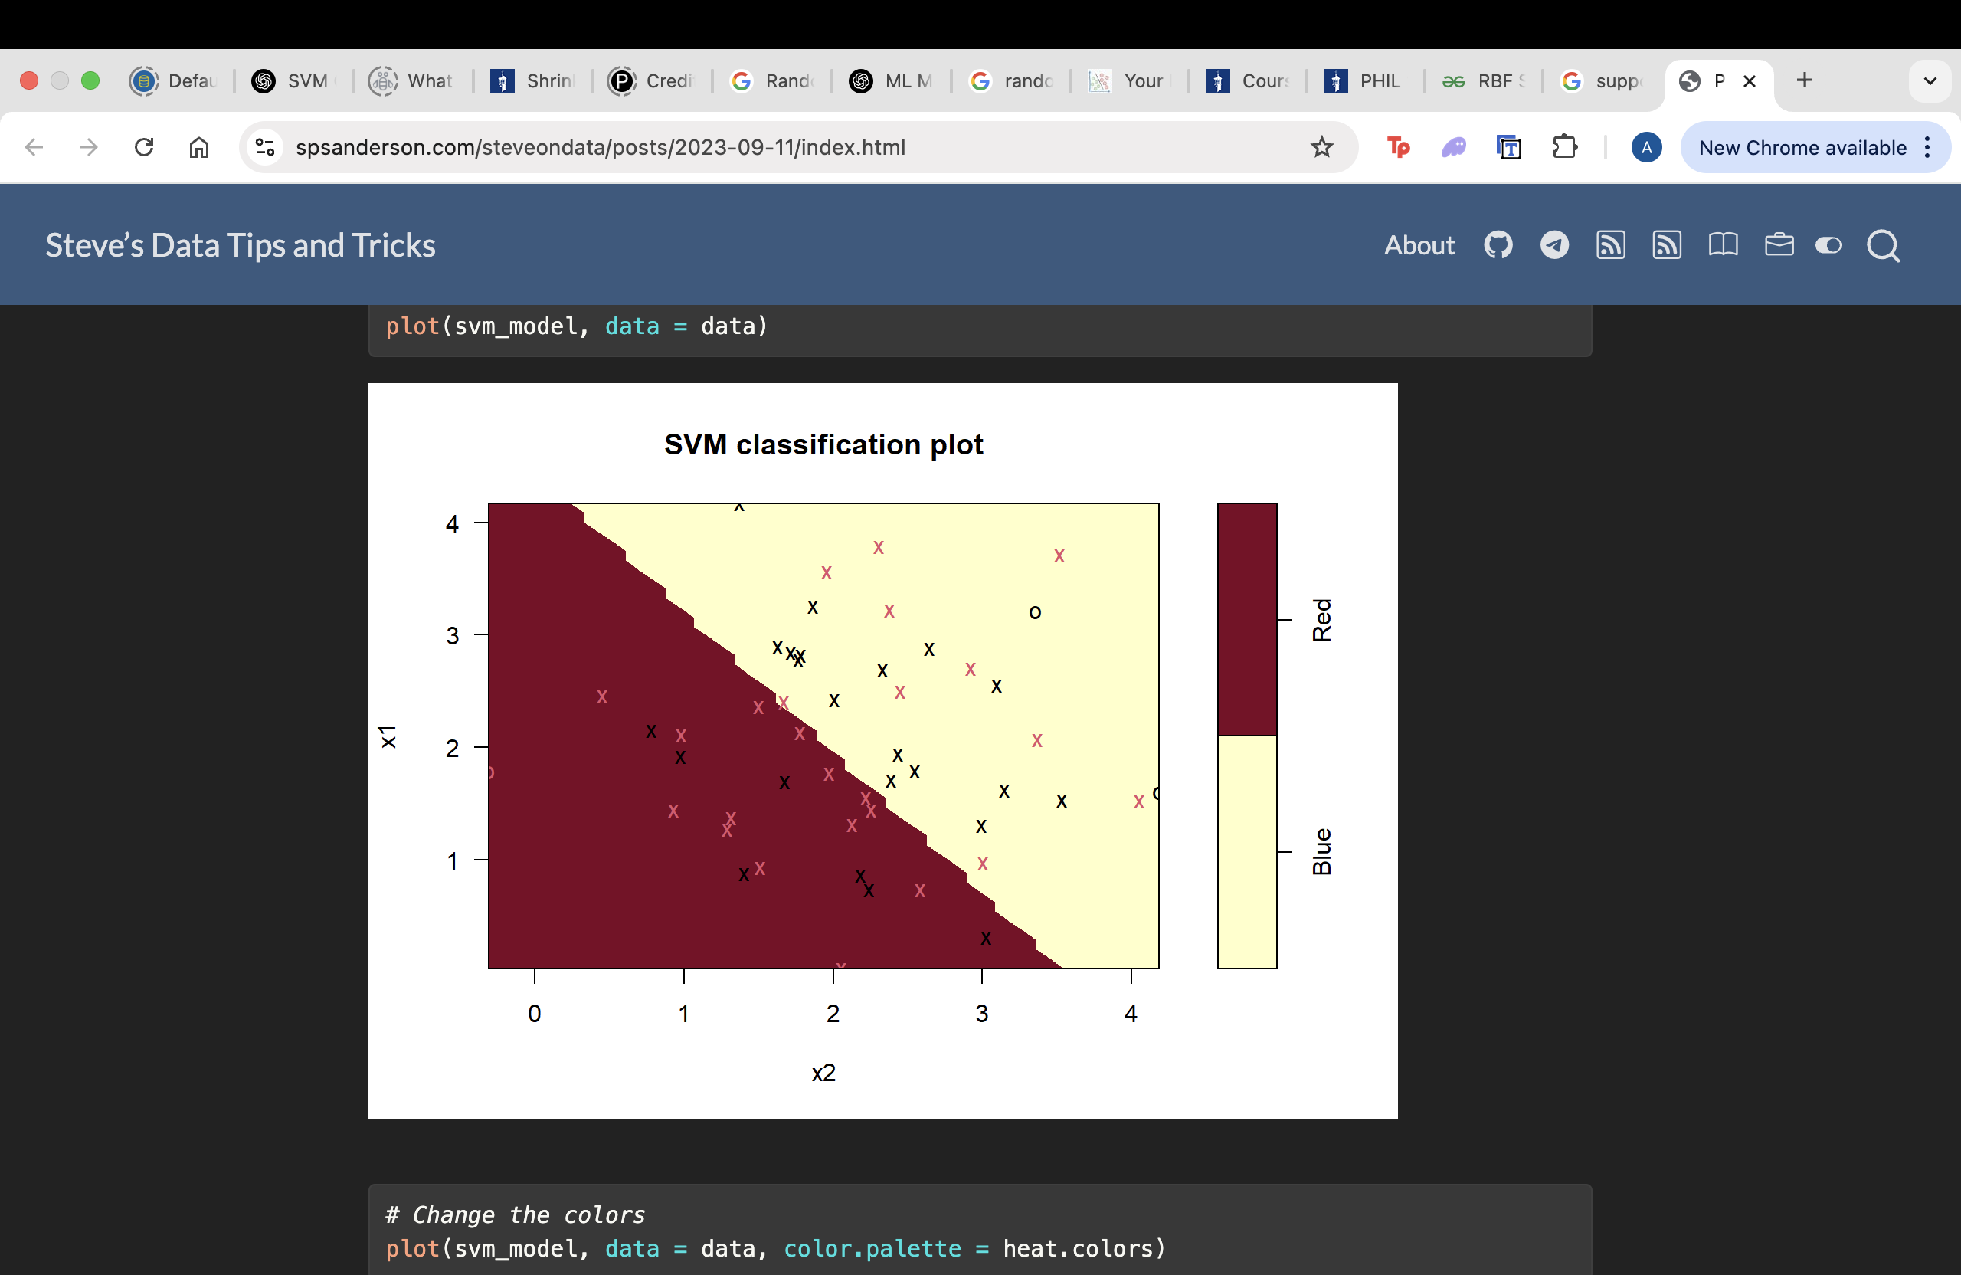

**LDA (Linear Discriminant Analysis)**

Linear discriminant analysis, also known as normal discriminant analysis (NDA) or discriminant function analysis (DFA), follows a generative model framework. This means LDA algorithms model the data distribution for each class and use Bayes' theorem1 to classify new data points. Bayes calculates conditional probabilities—the probability of an event given some other event has occurred. LDA algorithms make predictions by using Bayes to calculate the probability of whether an input data set will belong to a particular output. For a review of Bayesian statistics and how it impacts supervised learning algorithms, see Naïve Bayes classifiers. LDA works by identifying a linear combination of features that separates or characterizes two or more classes of objects or events. LDA does this by projecting data with two or more dimensions into one dimension so that it can be more easily classified. The technique is, therefore, sometimes referred to as dimensionality reduction. This versatility ensures that LDA can be used for multi-class data classification problems, unlike logistic regression, which is limited to binary classification. LDA is thus often applied to enhance the operation of other learning classification algorithms such as decision tree, random forest or support vector machines (SVM). (*IBM, Linear Discriminant Analysis*)

The key assumption of a LDA model are that predictor variables are normally distributed within each class. Another is that the classes have equal covariances matrices or that they share the same variance structure. Conversely, this means that, if the output classes share a similar covariance structure, the LDA model is highly preferred as compared to QDA.

The accuracy I had for this model was 81.6% accuracy, with a kappa value of 0.289, this suggest that there is fair agreement. This brings the balanced accuracy down to 60%. This does much worse as compared to the SVM models, that have balanced accuracy values of up to 75%.

**Neural Networks**

A neural network is a machine learning program, or model, that makes decisions in a manner similar to the human brain, by using processes that mimic the way biological neurons work together to identify phenomena, weight options, and arrive at conclusions. Every neural network consists of layers of nodes or artificial neurons, an input layer, one or more hidden layers, and an output layer. Each node connects to others and has its own associated weight and threshold. If the output of any individual node is above the specified threshold value, that node is activated, sending data to the next layer of the network. Otherwise, no data is passed along to the next layer of the network.

As beneficial as neural networks are, there are many assumptions the model makes. One is that it assumes the training data is large and diverse enough to create meaningful patterns, small datasets can lead to overfitting. Another is that scaling is a very necessary thing to do because the model is quite sensitive to input features and relative weights of input variables. This ensures that all the features will be evenly distributed during the training process. One more assumption is that neural networks generally assume that each observation is independent of one another and distributed evenly as well.

Ideally it is advised that the tuning parameters like number of hidden nodes in a layer be tuned in a grid search or played around with to find the appropriate number of hidden layers. For the case of the project, I chose to have one hidden layer with 5 neurons. Also I reduced the number of predictor variables substantially to save time computationally so that I can put together my knitted file soon. I’m pretty certain the model could have done much better than it did in this case, if provided with more predictor variables to work with. I picked the 6 best variables using the best subset method in the *leaps* library.

The accuracy of the neural network model was 83% with a kappa value of 0.34, which suggests fair agreement. The balanced accuracy of this model was 63%. This model had the highest overall prediction capacity of 83%, but had a mediocre balanced accuracy.

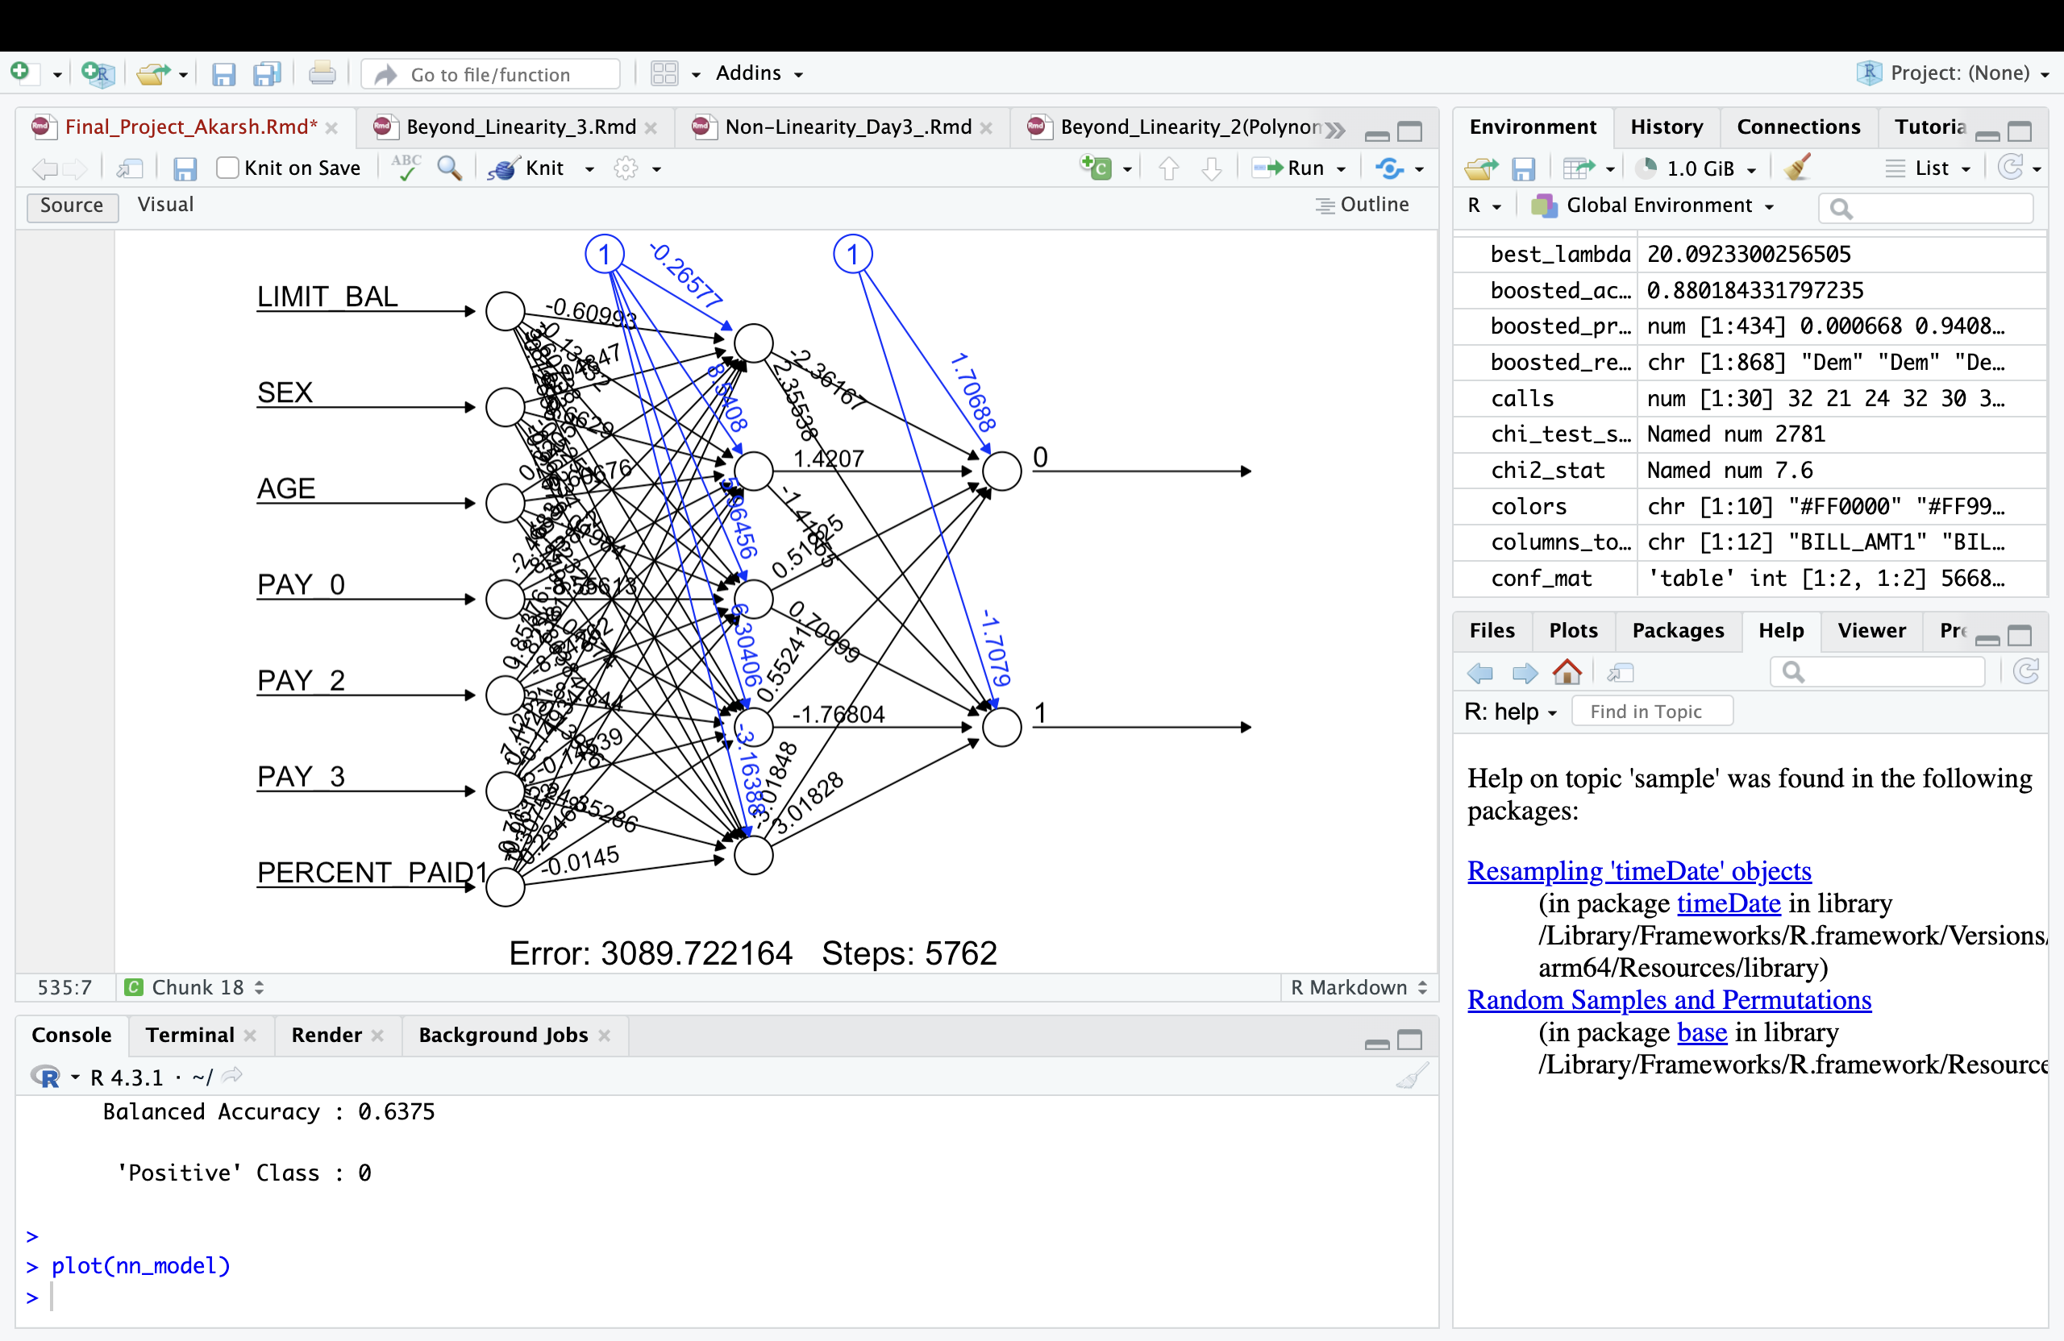

**Conclusion**

This project investigates two core predictive tasks using a credit card default dataset: (1) estimating an appropriate credit card balance limit using regression models, and (2) predicting the likelihood of a user defaulting on their payments using classification models. The dataset includes demographic and financial features such as age, sex, education, marriage status, bill and payment history over six months, and a binary default status.

**Regression Task: Predicting Credit Limit**

Five models were applied:

* **Linear Regression**: Baseline model with RMSE ≈ 117,234. Residual plots suggested nonlinearity in the data.
* **Ridge Regression**: Slight improvement with RMSE ≈ 116,581, indicating multicollinearity among predictors.
* **Lasso Regression**: Marginally better RMSE ≈ 116,499, helping with feature selection.
* **Random Forest**: Significant improvement (RMSE ≈ 106,709), capturing nonlinearity and interactions.
* **XGBoost**: Comparable performance (RMSE ≈ 106,852), showing potential for further tuning.

**Classification Task: Predicting Default**

Six models were tested to classify whether a user will default:

* **Logistic Regression**: Accuracy 82.3%, kappa 0.36, balanced accuracy 65%.
* **SVM (Linear)**: Accuracy 81.2%, kappa 0.27, balanced accuracy 75%.
* **SVM (Radial)**: Accuracy 81.6%, kappa 0.32, balanced accuracy 74%.
* **LDA**: Accuracy 81.6%, kappa 0.289, but lower balanced accuracy (60%).
* **Neural Network**: Highest accuracy of 83%, kappa 0.34, balanced accuracy 63%.

Preprocessing included transforming categorical features into factors, handling missing values, and engineering “percent paid” features from bill and payment data.

**Application and Further development**

Credit card debt in the U.S. is rising, and write-off rates like Capital One’s 6.1% underscore the importance of predicting defaults and responsibly assigning credit limits. Improving these predictions can reduce losses and optimize lending strategies for financial institutions.

If there is one thing I may have learnt through this project, it is that the model we choose does not completely determine the accuracy, a large part of the accuracy of the model lies in aspects like, tuning, and preprocessing data appropriately.

**Works Cited**

*"Linear Regression."* Berkley Stats, <https://www.stat.berkeley.edu/~s133/Lr-a.html>

“*Random Forest Algorithm in Machine Learning*”<https://www.geeksforgeeks.org/random-forest-algorithm-in-machine-learning/>

“*Geeks for Geeks, XGBoost*” <https://www.geeksforgeeks.org/xgboost/>

“*Neural Networks, IBM*”, <https://www.ibm.com/think/topics/neural-networks>

“*Support Vector Machine Algorithm*.” *GeeksforGeeks*.

<https://www.geeksforgeeks.org/support-vector-machine-algorithm/>